*Florida International University*

*School of Computing and Information Sciences*

CIS 4911 - Senior Capstone Project

Software Engineering Focus

Feature Document

User Story # 546

**Team Member:**

Garrett Lemieux

**Product Owner(s)**:

Francisco Ortega

**Mentor(s)**:

Francisco Ortega

**Instructor**: Masoud Sadjadi

# 

# **User Story**

* As a Developer I want preset Leap Motion gestures so I can assign functionality to them.

## **Use Case**

Gesture Implementation and Recognition

* Details:
* Actor:
  + Developer
* Pre-conditions:
  + Leap Motion device is installed and working.
  + Developer has Leap Motion SDK.
* Description:
  + Use case begins when developer needs a preset gesture for paint program implementation.
  + Developer can interact with leap motion using gestures and the leap motion can detect this gestures that can be used within User Interface and Paint Program.
  + When developer makes gesture over leap motion device he or she is informed that the gesture was read by leap motion by reading the output.
* Post-conditions:
  + Developer can read a successful gesture recognition by leap motion through the output window provided.
* Decision Support:
  + Frequency: High , Gestures will be needed to select modes and change the state of paint program.
  + Criticality: High , User feedback and UI can not be implemented without gestures.
  + Risk: High, Had to learn new technology
* Constraints:
  + Have to use the SDK provided by leap motion
  + Can only receive and manipulate data received by Leap Motion Service.
* Usability:
  + Once gesture create all have to do is apply it to the paint program.
* Reliability
  + Reliable
* Performance
  + Performance High , low failure
* Supportability
  + Leap Motion Device
* Modification History:
  + Owner: Garrett Lemieux
  + Initiation Date 02/01/2015
  + Date last Modified: 02/15/2015

## **Sequence Diagram**

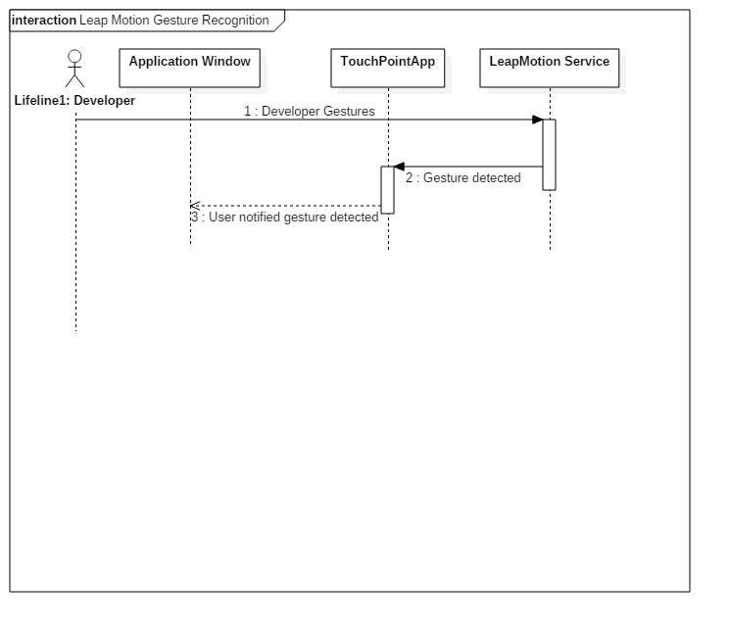

## 

## 

## 

## 

## 

## 

## 

## **Class Diagram**

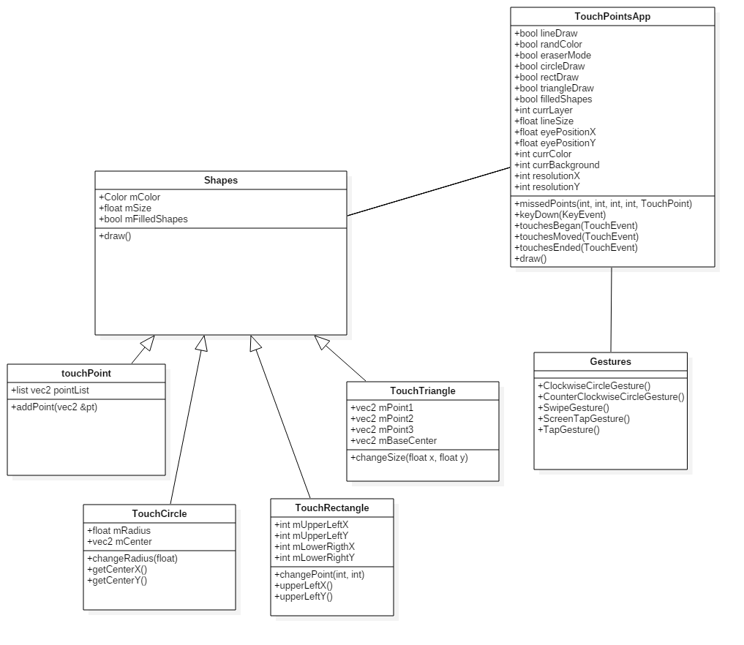

## **Unit Test**

* A developer can make the developed gestures such as swipe, clockwise circle, counterclockwise circle, screen tap and tap gestures.
* Either hand can be read with same accuracy

## **Integration Testing**

* The ability to gestures can be implemented within touchPoints app.

## **User Guide**

* User simply makes desired gesture over the leap motion using either hand and the leap motion service recognizes valid gestures.